Министерство образования и молодежной политики Свердловской области



ГАПОУ СО «Екатеринбургский колледж транспортного строительства»

# Отчет по программе «Практическое занятие 13-17»

Выполнил: Меньшиков Артур Андреевич

Группа: ПР-22

Преподаватель: Мирошниченко Г. В.

2023

**Задание:**

Задание 1:

Реализуйте в Android Studio 4 экрана (Splash Screen, Onboarding, Login, Main, Profile, используя макет ConstraintLayout и элементы навигации) <https://www.figma.com/file/gAonPFbfoILOIIyNHgwY41/MAD-Meditation-> App?node-id=1%3A659

Задание 2:

Используя предыдущий пример, реализуйте в Android Studio 3 экрана (Signin Screen, Main Screen, Profile Screen, используя макет ConstraintLayout и элементы навигации) <https://www.figma.com/file/wwDCPGa4AyPXdeuFnKU95M/KOD1.4->Variant2?node-id=0%3A1

**Входные и выходные данные**

Задание 1:

Email – textEmailAddress

Password – text

Задание 2:

Email – textEmailAddress

Password – text

**Листинг программы (если есть)**

Задание 1:

Activity_main.xml

<?xml version="1.0" encoding="utf-8"?>  
<androidx.constraintlayout.widget.ConstraintLayout xmlns:android="http://schemas.android.com/apk/res/android"  
 xmlns:app="http://schemas.android.com/apk/res-auto"  
 xmlns:tools="http://schemas.android.com/tools"  
 android:layout_width="match_parent"  
 android:layout_height="match_parent"  
 android:background="@drawable/background"  
 tools:context=".ui.theme.MainActivity2">  
  
 <ImageView  
 android:layout_width="200dp"  
 android:layout_height="200dp"  
 android:layout_marginStart="87dp"  
 android:layout_marginTop="300dp"  
 android:layout_marginEnd="87dp"  
 android:layout_marginBottom="300dp"  
 android:src="@drawable/logoand"  
 app:layout_constraintBottom_toBottomOf="parent"  
 app:layout_constraintEnd_toEndOf="parent"  
 app:layout_constraintStart_toStartOf="parent"  
 app:layout_constraintTop_toTopOf="parent" />  
</androidx.constraintlayout.widget.ConstraintLayout>

Activity_launch.xml

<?xml version="1.0" encoding="utf-8"?>  
<androidx.constraintlayout.widget.ConstraintLayout xmlns:android="http://schemas.android.com/apk/res/android"  
 xmlns:app="http://schemas.android.com/apk/res-auto"  
 xmlns:tools="http://schemas.android.com/tools"  
 android:layout_width="match_parent"  
 android:layout_height="match_parent"  
 android:background="@drawable/background"  
 tools:context=".ui.theme.LaunchActivity">  
  
 <ImageView  
 android:id="@+id/imageView"  
 android:layout_width="200dp"  
 android:layout_height="200dp"  
 android:layout_marginTop="100dp"  
 android:src="@drawable/logoand"  
 app:layout_constraintBottom_toBottomOf="parent"  
 app:layout_constraintEnd_toEndOf="parent"  
 app:layout_constraintStart_toStartOf="parent"  
 app:layout_constraintTop_toTopOf="parent"  
 app:layout_constraintVertical_bias="0.0" />  
  
 <androidx.appcompat.widget.AppCompatButton  
 android:id="@+id/button"  
 android:layout_width="0dp"  
 android:layout_height="70dp"  
 android:layout_marginStart="27dp"  
 android:layout_marginTop="95dp"  
 android:layout_marginEnd="27dp"  
 android:background="@drawable/button"  
 android:gravity="center"  
 android:textSize="25sp"  
 android:textColor="#FFFFFF"  
 android:onClick="login"  
 android:text="@string/login"  
 android:textAppearance="@style/TextAppearance.AppCompat.Body2"  
 app:layout_constraintBottom_toBottomOf="parent"  
 app:layout_constraintEnd_toEndOf="parent"  
 app:layout_constraintHorizontal_bias="0.0"  
 app:layout_constraintStart_toStartOf="parent"  
 app:layout_constraintTop_toBottomOf="@+id/imageView"  
 app:layout_constraintVertical_bias="0.541" />  
  
 <TextView  
 android:id="@+id/textView"  
 android:layout_width="232dp"  
 android:layout_height="72dp"  
 android:layout_marginStart="100dp"  
 android:layout_marginTop="32dp"  
 android:layout_marginEnd="100dp"  
 android:text="@string/main_text"  
 android:textAlignment="center"  
 android:textColor="#FFFFFF"  
 android:textSize="20sp"  
 android:typeface="normal"  
 app:layout_constraintBottom_toBottomOf="parent"  
 app:layout_constraintEnd_toEndOf="parent"  
 app:layout_constraintHorizontal_bias="0.498"  
 app:layout_constraintStart_toStartOf="parent"  
 app:layout_constraintTop_toBottomOf="@+id/imageView"  
 app:layout_constraintVertical_bias="0.182" />  
  
 <TextView  
 android:id="@+id/textView2"  
 android:layout_width="131dp"  
 android:layout_height="46dp"  
 android:layout_marginTop="32dp"  
 android:text="@string/hello"  
 android:textAlignment="center"  
 android:textColor="#FFFFFF"  
 android:textSize="34sp"  
 android:typeface="normal"  
 app:layout_constraintBottom_toTopOf="@+id/textView"  
 app:layout_constraintEnd_toEndOf="parent"  
 app:layout_constraintStart_toStartOf="parent"  
 app:layout_constraintTop_toBottomOf="@+id/imageView"  
 app:layout_constraintVertical_bias="1.0" />  
  
 <TextView  
 android:id="@+id/textView3"  
 android:layout_width="wrap_content"  
 android:layout_height="wrap_content"  
 android:layout_marginStart="35dp"  
 android:layout_marginEnd="35dp"  
 android:text="@string/main_text_under"  
 android:textAlignment="center"  
 android:textColor="#FFFFFF"  
 android:textSize="20sp"  
 android:typeface="normal"  
 app:layout_constraintBottom_toBottomOf="parent"  
 app:layout_constraintEnd_toEndOf="parent"  
 app:layout_constraintStart_toStartOf="parent"  
 app:layout_constraintTop_toBottomOf="@+id/button"  
 app:layout_constraintVertical_bias="0.329" />  
  
</androidx.constraintlayout.widget.ConstraintLayout>

Activity_login.xml

<?xml version="1.0" encoding="utf-8"?>  
<androidx.constraintlayout.widget.ConstraintLayout xmlns:android="http://schemas.android.com/apk/res/android"  
 xmlns:app="http://schemas.android.com/apk/res-auto"  
 xmlns:tools="http://schemas.android.com/tools"  
 android:layout_width="match_parent"  
 android:layout_height="match_parent"  
 android:background="@color/back_login"  
 tools:context=".ui.theme.LoginActivity">  
  
 <ImageView  
 android:id="@+id/imageView3"  
 android:layout_width="412dp"  
 android:layout_height="437dp"  
 android:layout_marginTop="487dp"  
 android:src="@drawable/grouplist"  
 app:layout_constraintBottom_toBottomOf="parent"  
 app:layout_constraintEnd_toEndOf="parent"  
 app:layout_constraintStart_toStartOf="parent"  
 app:layout_constraintTop_toTopOf="parent" />  
  
 <ImageView  
 android:id="@+id/imageView4"  
 android:layout_width="50dp"  
 android:layout_height="50dp"  
 android:layout_marginStart="40dp"  
 android:layout_marginTop="100dp"  
 android:src="@drawable/logoand"  
 app:layout_constraintStart_toStartOf="parent"  
 app:layout_constraintTop_toTopOf="parent" />  
  
 <TextView  
 android:id="@+id/textView4"  
 android:layout_width="wrap_content"  
 android:layout_height="wrap_content"  
 android:layout_marginStart="40dp"  
 android:layout_marginTop="20dp"  
 android:text="@string/sign_in"  
 android:textColor="#FFFFFF"  
 android:textSize="30sp"  
 android:typeface="normal"  
 app:layout_constraintStart_toStartOf="parent"  
 app:layout_constraintTop_toBottomOf="@+id/imageView4" />  
  
 <EditText  
 android:id="@+id/email"  
 android:layout_width="match_parent"  
 android:layout_height="60dp"  
 android:layout_marginStart="35dp"  
 android:layout_marginTop="100dp"  
 android:layout_marginEnd="35dp"  
 android:textSize="18sp"  
 android:backgroundTint="@color/gray"  
 android:hint="@string/email"  
 android:paddingLeft="20dp"  
 android:textColorHint="@color/gray"  
 app:layout_constraintEnd_toEndOf="parent"  
 app:layout_constraintStart_toStartOf="parent"  
 app:layout_constraintTop_toBottomOf="@+id/textView4" />  
 <EditText  
 android:id="@+id/password"  
 android:layout_width="match_parent"  
 android:layout_height="60dp"  
 android:layout_marginStart="35dp"  
 android:layout_marginTop="20dp"  
 android:layout_marginEnd="35dp"  
 android:textSize="18sp"  
 android:backgroundTint="@color/gray"  
 android:hint="@string/password"  
 android:paddingLeft="20dp"  
 android:textColorHint="@color/gray"  
 app:layout_constraintEnd_toEndOf="parent"  
 app:layout_constraintStart_toStartOf="parent"  
 app:layout_constraintTop_toBottomOf="@+id/email"/>  
  
 <androidx.appcompat.widget.AppCompatButton  
 android:id="@+id/button"  
 android:layout_width="0dp"  
 android:layout_height="70dp"  
 android:layout_marginStart="27dp"  
 android:layout_marginTop="50dp"  
 android:layout_marginEnd="27dp"  
 android:textSize="25sp"  
 android:textColor="#FFFFFF"  
 android:background="@drawable/button"  
 android:text="@string/sign_in"  
 android:onClick="signin"  
 android:gravity="center"  
 android:textAppearance="@style/TextAppearance.AppCompat.Body2"  
 app:layout_constraintEnd_toEndOf="parent"  
 app:layout_constraintStart_toStartOf="parent"  
 app:layout_constraintTop_toBottomOf="@+id/password"/>  
  
 <androidx.appcompat.widget.AppCompatButton  
 android:id="@+id/button_profile"  
 android:layout_width="0dp"  
 android:layout_height="70dp"  
 android:layout_marginStart="27dp"  
 android:layout_marginTop="50dp"  
 android:layout_marginEnd="27dp"  
 android:textSize="25sp"  
 android:textColor="#FFFFFF"  
 android:background="@drawable/button"  
 android:text="@string/profile"  
 android:onClick="Profile"  
 android:gravity="center"  
 android:textAppearance="@style/TextAppearance.AppCompat.Body2"  
 app:layout_constraintEnd_toEndOf="parent"  
 app:layout_constraintStart_toStartOf="parent"  
 app:layout_constraintTop_toBottomOf="@+id/button"/>  
  
  
</androidx.constraintlayout.widget.ConstraintLayout>

Activity_menu.xml

<?xml version="1.0" encoding="utf-8"?>  
<androidx.constraintlayout.widget.ConstraintLayout xmlns:android="http://schemas.android.com/apk/res/android"  
 xmlns:app="http://schemas.android.com/apk/res-auto"  
 xmlns:tools="http://schemas.android.com/tools"  
 android:id="@+id/container"  
 android:background="@color/back_login"  
 android:layout_width="match_parent"  
 android:layout_height="match_parent">  
  
 <com.google.android.material.bottomnavigation.BottomNavigationView  
 android:id="@+id/nav_view"  
 android:layout_width="0dp"  
 android:layout_height="wrap_content"  
 android:background="@color/back_login"  
 app:itemIconTint="@drawable/bottom_icon"  
 app:itemRippleColor="@null"  
 app:labelVisibilityMode="unlabeled"  
 android:paddingLeft="35dp"  
 android:paddingRight="35dp"  
 app:layout_constraintBottom_toBottomOf="parent"  
 app:layout_constraintLeft_toLeftOf="parent"  
 app:layout_constraintRight_toRightOf="parent"  
 app:menu="@menu/bottom_nav_menu" />  
  
 <ImageView  
 android:id="@+id/imageViewprof"  
 android:layout_width="36dp"  
 android:layout_height="35dp"  
 android:layout_marginTop="66dp"  
 android:layout_marginEnd="29dp"  
 android:src="@drawable/elipse"  
 app:layout_constraintEnd_toEndOf="parent"  
 app:layout_constraintTop_toTopOf="parent" />  
  
 <ImageView  
 android:id="@+id/imageViewsett"  
 android:layout_width="23dp"  
 android:layout_height="18dp"  
 android:layout_marginStart="25dp"  
 android:layout_marginTop="75dp"  
 android:src="@drawable/hamburger"  
 app:layout_constraintStart_toStartOf="parent"  
 app:layout_constraintTop_toTopOf="parent" />  
  
  
  
 <LinearLayout  
 android:id="@+id/feel_rec_linear"  
 android:layout_width="500dp"  
 android:layout_height="100dp"  
 android:orientation="horizontal"  
 android:layout_marginTop="20dp"  
 app:layoutManager="androidx.recyclerview.widget.LinearLayoutManager"  
 app:layout_constraintTop_toBottomOf="@+id/how"  
 android:layout_marginStart="25dp"  
 app:layout_constraintStart_toStartOf="parent">  
  
 <LinearLayout  
 android:layout_width="wrap_content"  
 android:layout_height="wrap_content"  
 android:orientation="vertical">  
  
 <ImageButton  
 android:id="@+id/calm"  
 android:layout_width="62dp"  
 android:layout_height="65dp"  
 android:layout_marginHorizontal="15dp"  
 android:background="@drawable/button_feel"  
 android:contentDescription="@string/calm_text"  
 android:src="@drawable/calm_ic" />  
 <TextView  
 android:layout_width="wrap_content"  
 android:layout_height="wrap_content"  
 android:text="@string/calm_text"  
 android:textColor="@color/white"  
 android:textSize="12sp"  
 android:layout_marginHorizontal="10dp"  
 app:layout_constraintEnd_toEndOf="parent"  
 app:layout_constraintStart_toStartOf="parent"  
 app:layout_constraintTop_toBottomOf="@+id/calm"  
 />  
  
 </LinearLayout>  
  
  
<LinearLayout  
 android:layout_width="wrap_content"  
 android:layout_height="wrap_content"  
 android:orientation="vertical">  
  
 <ImageButton  
 android:id="@+id/relax"  
 android:layout_width="62dp"  
 android:layout_height="65dp"  
 android:layout_marginHorizontal="15dp"  
 android:background="@drawable/button_feel"  
 android:contentDescription="@string/relax_text"  
 android:src="@drawable/relax_ic" />  
 <TextView  
 android:layout_width="wrap_content"  
 android:layout_height="wrap_content"  
 android:text="@string/relax_text"  
 android:textColor="@color/white"  
 android:textSize="12sp"  
 android:layout_marginEnd="10dp"  
 app:layout_constraintEnd_toEndOf="parent"  
 app:layout_constraintStart_toStartOf="parent"  
 app:layout_constraintTop_toBottomOf="@+id/relax"  
 />  
  
</LinearLayout>  
  
 <LinearLayout  
 android:layout_width="wrap_content"  
 android:layout_height="wrap_content"  
 android:orientation="vertical">  
  
 <ImageButton  
 android:id="@+id/focus"  
 android:layout_width="62dp"  
 android:layout_height="65dp"  
 android:layout_marginHorizontal="15dp"  
 android:background="@drawable/button_feel"  
 android:contentDescription="@string/focus_text"  
 android:src="@drawable/focus_ic" />  
  
 <TextView  
 android:layout_width="wrap_content"  
 android:layout_height="wrap_content"  
 android:text="@string/focus_text"  
 android:textColor="@color/white"  
 android:textSize="12sp"  
 android:layout_marginHorizontal="1dp"  
 app:layout_constraintEnd_toEndOf="parent"  
 app:layout_constraintStart_toStartOf="parent"  
 app:layout_constraintTop_toBottomOf="@+id/focus"  
 />  
 </LinearLayout>  
  
 <LinearLayout  
 android:layout_width="wrap_content"  
 android:layout_height="wrap_content"  
 android:orientation="vertical">  
  
 <ImageButton  
 android:id="@+id/anxious"  
 android:layout_width="62dp"  
 android:layout_height="65dp"  
 android:layout_marginHorizontal="15dp"  
 android:background="@drawable/button_feel"  
 android:contentDescription="@string/anxious_text"  
 android:src="@drawable/calm_ic" />  
  
 <TextView  
 android:layout_width="wrap_content"  
 android:layout_height="wrap_content"  
 android:text="@string/anxious_text"  
 android:textColor="@color/white"  
 android:textSize="12sp"  
 android:layout_marginHorizontal="10dp"  
 app:layout_constraintEnd_toEndOf="parent"  
 app:layout_constraintStart_toStartOf="parent"  
 app:layout_constraintTop_toBottomOf="@+id/anxious"/>  
  
  
 </LinearLayout>  
  
 <LinearLayout  
 android:layout_width="wrap_content"  
 android:layout_height="wrap_content"  
 android:orientation="vertical">  
  
 <ImageView  
 android:id="@+id/dop"  
 android:layout_width="62dp"  
 android:layout_height="65dp"  
 android:layout_marginHorizontal="15dp"  
 android:background="@drawable/button_feel"  
 android:src="@drawable/calm_ic" />  
  
 <TextView  
 android:id="@+id/dop_text"  
 android:layout_width="wrap_content"  
 android:layout_height="wrap_content"  
 android:text="@string/dop"  
 android:textColor="@color/white"  
 android:textSize="12sp"  
 android:layout_marginHorizontal="30dp"  
 app:layout_constraintEnd_toEndOf="parent"  
 app:layout_constraintStart_toStartOf="parent"  
 app:layout_constraintTop_toBottomOf="@+id/dop"/>  
  
 </LinearLayout>  
  
 </LinearLayout>  
  
 <ImageView  
 android:id="@+id/meditation_but"  
 android:layout_marginTop="22dp"  
 android:layout_marginStart="25dp"  
 android:layout_marginEnd="25dp"  
 android:layout_width="339dp"  
 android:layout_height="170dp"  
 android:layout_marginHorizontal="15dp"  
 android:background="@drawable/button_feel"  
 app:layout_constraintEnd_toEndOf="parent"  
 app:layout_constraintTop_toBottomOf="@+id/feel_rec_linear" />  
  
 <TextView  
 android:layout_width="wrap_content"  
 android:layout_height="wrap_content"  
 android:layout_marginTop="44dp"  
 android:layout_marginLeft="30dp"  
 android:text="@string/hedname_med"  
 android:textColor="@color/black"  
 android:textSize="23sp"  
 app:layout_constraintStart_toStartOf="@+id/meditation_but"  
 app:layout_constraintTop_toBottomOf="@+id/feel_rec_linear" />  
  
 <TextView  
 android:layout_width="wrap_content"  
 android:layout_height="wrap_content"  
 android:layout_marginTop="78dp"  
 android:layout_marginLeft="30dp"  
 android:text="@string/descripton_med"  
 android:textColor="@color/black"  
 android:textSize="13sp"  
 app:layout_constraintStart_toStartOf="@+id/meditation_but"  
 app:layout_constraintTop_toBottomOf="@+id/feel_rec_linear" />  
  
 <ImageView  
 android:layout_width="wrap_content"  
 android:layout_height="wrap_content"  
 android:layout_marginTop="50dp"  
 android:layout_marginLeft="168dp"  
 android:background="@drawable/state_img_1"  
 app:layout_constraintStart_toStartOf="@+id/meditation_but"  
 app:layout_constraintTop_toBottomOf="@+id/feel_rec_linear"  
 />  
  
 <Button  
 android:layout_width="138dp"  
 android:layout_height="39dp"  
 android:layout_marginTop="130dp"  
 android:layout_marginLeft="48dp"  
 android:text="подробнее"  
 android:textSize="15dp"  
 android:textColor="@color/white"  
 android:background="@drawable/mini_button"  
 app:layout_constraintStart_toStartOf="@+id/meditation_but"  
 app:layout_constraintTop_toBottomOf="@+id/feel_rec_linear" />  
  
  
 <ImageView  
 android:id="@+id/cardio_but"  
 android:layout_marginTop="218dp"  
 android:layout_marginStart="25dp"  
 android:layout_marginEnd="25dp"  
 android:layout_width="339dp"  
 android:layout_height="170dp"  
 android:layout_marginHorizontal="15dp"  
 android:background="@drawable/button_feel"  
 app:layout_constraintEnd_toEndOf="parent"  
 app:layout_constraintTop_toBottomOf="@+id/feel_rec_linear" />  
  
  
  
  
  
  
  
  
 <ImageView  
 android:id="@+id/imageView3"  
 android:layout_width="50dp"  
 android:layout_height="50dp"  
 android:layout_marginTop="61dp"  
 android:src="@drawable/logoand"  
 app:layout_constraintEnd_toEndOf="parent"  
 app:layout_constraintStart_toStartOf="parent"  
 app:layout_constraintTop_toTopOf="parent" />  
  
 <TextView  
 android:id="@+id/welcome_back_text"  
 android:layout_width="match_parent"  
 android:layout_height="wrap_content"  
 android:layout_marginStart="25dp"  
 android:layout_marginTop="30dp"  
 android:text="@string/welcome_text"  
 android:textColor="@color/white"  
 android:textSize="30sp"  
 app:layout_constraintStart_toStartOf="parent"  
 app:layout_constraintTop_toBottomOf="@+id/imageView3" />  
 <TextView  
 android:id="@+id/how"  
 android:layout_width="match_parent"  
 android:layout_height="wrap_content"  
 android:layout_marginStart="25dp"  
 android:layout_marginTop="5dp"  
 android:layout_marginEnd="25dp"  
 android:text="@string/feeling"  
 android:textColor="@color/gray"  
 android:textSize="20sp"  
 android:autoSizeMinTextSize="15sp"  
 app:layout_constraintEnd_toEndOf="parent"  
 app:layout_constraintStart_toStartOf="parent"  
 app:layout_constraintTop_toBottomOf="@+id/welcome_back_text"/>  
  
  
</androidx.constraintlayout.widget.ConstraintLayout>

Big_button.xml

<?xml version="1.0" encoding="utf-8"?>  
<shape xmlns:android="http://schemas.android.com/apk/res/android">  
 <solid android:color="@color/for_big_button"></solid>  
 <corners android:radius="20px"></corners>  
</shape>

Bottom_icon.xml

<?xml version="1.0" encoding="utf-8"?>  
<selector xmlns:android="http://schemas.android.com/apk/res/android">  
<item android:state_selected="true" android:color = "@color/white"/>  
 <item android:color = "#929999"/>  
</selector>

Button.xml

<?xml version="1.0" encoding="utf-8"?>  
<shape xmlns:android="http://schemas.android.com/apk/res/android">  
 <solid android:color="@color/green_blue"></solid>  
 <corners android:radius="10px"></corners>  
</shape>

Button_feel.xml

<?xml version="1.0" encoding="utf-8"?>  
<shape xmlns:android="http://schemas.android.com/apk/res/android">  
 <solid android:color="@color/white"></solid>  
 <corners android:radius="20px"></corners>  
</shape>

Mini_button.xml

<?xml version="1.0" encoding="utf-8"?>  
<shape xmlns:android="http://schemas.android.com/apk/res/android">  
 <solid android:color="@color/black"></solid>  
 <corners android:radius="10px"></corners>  
</shape>

Image_shape.xml

<?xml version="1.0" encoding="utf-8"?>  
<shape xmlns:android="http://schemas.android.com/apk/res/android">  
<corners android:radius="20dp"/><solid android:color="@color/white"/>  
</shape>

Colors.xml

<?xml version="1.0" encoding="utf-8"?>  
<resources>  
 <color name="purple_200">#FFBB86FC</color>  
 <color name="purple_500">#FF6200EE</color>  
 <color name="purple_700">#FF3700B3</color>  
 <color name="teal_200">#FF03DAC5</color>  
 <color name="teal_700">#FF018786</color>  
 <color name="black">#FF000000</color>  
 <color name="white">#FFFFFFFF</color>  
 <color name="green_blue">#7C9A92</color>  
 <color name="for_big_button">#F7F3F0</color>  
 <color name="for_list">#D3D6D6</color>  
 <color name="back_login">#253334</color>  
 <color name="gray">#BEC2C2</color>  
</resources>

String.xml

<resources>  
 <string name="app_name">prak13</string>  
 <string name="login">Войти в аккаунт</string>  
 <string name="main_text">Нaаслаждайся отборочными. \n Будь внимателен. \n Делай хорошо.</string>  
 <string name="hello">ПРИВЕТ</string>  
 <string name="main_text_under">Еще нет аккаунта? Зарегистрируйтесь</string>  
 <string name="sign_in">Sign in</string>  
 <string name="email">Email</string>  
 <string name="password">Пароль</string>  
 <string name="title_activity_menu">MenuActivity</string>  
 <string name="title_home">Home</string>  
 <string name="title_dashboard">Dashboard</string>  
 <string name="title_notifications">Notifications</string>  
 <string name="profile">Профиль</string>  
 <string name="feeling">Каким ты себя ощущаешь сегодня</string>  
 <string name="welcome_text">С возвращением, Артур!</string>  
 <string name="calm_text">Спокойным</string>  
 <string name="relax_text">Расслабленным</string>  
 <string name="focus_text">Сосредоточенным</string>  
 <string name="anxious_text">Взволнованным</string>  
 <string name="dop">dop</string>  
 <string name="descripton_med">Кратенькое описание \nблока с двумя строчками</string>  
 <string name="hedname_med">Загаловок блока</string>  
</resources>

Themes.xml

<?xml version="1.0" encoding="utf-8"?>  
<resources>  
 <style name="Theme.Prak13" parent="android:Theme.Material.Light.NoActionBar" />  
</resources>

Feel_adapter.xml

<?xml version="1.0" encoding="utf-8"?>  
<androidx.constraintlayout.widget.ConstraintLayout  
 xmlns:android="http://schemas.android.com/apk/res/android"  
 xmlns:app="http://schemas.android.com/apk/res-auto"  
 android:layout_width="65dp"  
 android:layout_height="85dp">  
  
 <LinearLayout  
 android:id="@+id/linearLayout"  
 android:layout_width="62dp"  
 android:layout_height="65dp"  
 android:background="@drawable/image_shape"  
 android:orientation="vertical"  
 app:layout_constraintEnd_toEndOf="parent"  
 app:layout_constraintStart_toStartOf="parent"  
 app:layout_constraintTop_toTopOf="parent">  
  
 <ImageView  
 android:id="@+id/img_feel"  
 android:layout_width="35dp"  
 android:layout_height="35dp"  
 android:layout_gravity="center"  
 android:layout_marginTop="10dp"  
 android:src="@drawable/ic_home"/>  
 </LinearLayout>  
 <TextView  
 android:id="@+id/text_feel"  
 android:layout_width="match_parent"  
 android:layout_height="20dp"  
 android:text=""  
 android:textSize="13dp"  
 app:layout_constraintEnd_toEndOf="parent"  
 app:layout_constraintStart_toStartOf="parent"  
 app:layout_constraintTop_toBottomOf="@+id/linearLayout"/>  
</androidx.constraintlayout.widget.ConstraintLayout>

Fragment_home.xml

<?xml version="1.0" encoding="utf-8"?>  
<androidx.constraintlayout.widget.ConstraintLayout xmlns:android="http://schemas.android.com/apk/res/android"  
 xmlns:app="http://schemas.android.com/apk/res-auto"  
 xmlns:tools="http://schemas.android.com/tools"  
 android:layout_width="match_parent"  
 android:layout_height="match_parent"  
 tools:context=".ui.theme.ui.home.HomeFragment">  
  
 <TextView  
 android:id="@+id/text_home"  
 android:layout_width="match_parent"  
 android:layout_height="wrap_content"  
 android:layout_marginStart="8dp"  
 android:layout_marginTop="8dp"  
 android:layout_marginEnd="8dp"  
 android:textAlignment="center"  
 android:textSize="20sp"  
 app:layout_constraintBottom_toBottomOf="parent"  
 app:layout_constraintEnd_toEndOf="parent"  
 app:layout_constraintStart_toStartOf="parent"  
 app:layout_constraintTop_toTopOf="parent" />  
</androidx.constraintlayout.widget.ConstraintLayout>

Fragment_listen.xml

<?xml version="1.0" encoding="utf-8"?>  
<androidx.constraintlayout.widget.ConstraintLayout xmlns:android="http://schemas.android.com/apk/res/android"  
 xmlns:app="http://schemas.android.com/apk/res-auto"  
 xmlns:tools="http://schemas.android.com/tools"  
 android:layout_width="match_parent"  
 android:layout_height="match_parent"  
 tools:context=".ui.theme.ui.listen.ListenFragment">  
  
 <TextView  
 android:id="@+id/text_dashboard"  
 android:layout_width="match_parent"  
 android:layout_height="wrap_content"  
 android:layout_marginStart="8dp"  
 android:layout_marginTop="8dp"  
 android:layout_marginEnd="8dp"  
 android:textAlignment="center"  
 android:textSize="20sp"  
 app:layout_constraintBottom_toBottomOf="parent"  
 app:layout_constraintEnd_toEndOf="parent"  
 app:layout_constraintStart_toStartOf="parent"  
 app:layout_constraintTop_toTopOf="parent" />  
</androidx.constraintlayout.widget.ConstraintLayout>

Fragment_profile.xml

<?xml version="1.0" encoding="utf-8"?>  
<androidx.constraintlayout.widget.ConstraintLayout xmlns:android="http://schemas.android.com/apk/res/android"  
 xmlns:app="http://schemas.android.com/apk/res-auto"  
 xmlns:tools="http://schemas.android.com/tools"  
 android:layout_width="match_parent"  
 android:layout_height="match_parent"  
 tools:context=".ui.theme.ui.profile.ProfileFragment">  
  
 <TextView  
 android:id="@+id/text_notifications"  
 android:layout_width="match_parent"  
 android:layout_height="wrap_content"  
 android:layout_marginStart="8dp"  
 android:layout_marginTop="8dp"  
 android:layout_marginEnd="8dp"  
 android:textAlignment="center"  
 android:textSize="20sp"  
 app:layout_constraintBottom_toBottomOf="parent"  
 app:layout_constraintEnd_toEndOf="parent"  
 app:layout_constraintStart_toStartOf="parent"  
 app:layout_constraintTop_toTopOf="parent" />  
</androidx.constraintlayout.widget.ConstraintLayout>

LaunchActivity.kt

package com.example.prak13.ui.theme  
  
import android.content.Intent  
import androidx.appcompat.app.AppCompatActivity  
import android.os.Bundle  
import android.os.CountDownTimer  
import android.view.View  
import com.example.prak13.MainActivity  
import com.example.prak13.R  
  
class LaunchActivity : AppCompatActivity() {  
 override fun onCreate(savedInstanceState: Bundle?) {  
 super.onCreate(savedInstanceState)  
 setContentView(R.layout.*activity_launch*)  
 val timer = object :CountDownTimer(3000, 1000){  
 override fun onTick(millisUntilFinished: Long) {  
 }  
  
 override fun onFinish() {  
 val intent = Intent(this@LaunchActivity, MainActivity::class.*java*)  
 startActivity(intent)  
 finish()  
 }  
 }  
 timer.start()  
 }  
  
 fun login(view: View) {  
 val intent = Intent(this,LoginActivity::class.*java*)  
 startActivity(intent)  
 }  
}

LoginActivity.kt

package com.example.prak13.ui.theme  
  
import androidx.appcompat.app.AppCompatActivity  
import android.os.Bundle  
import android.view.View  
import android.widget.EditText  
import androidx.appcompat.app.AlertDialog  
import com.example.prak13.R  
  
class LoginActivity : AppCompatActivity() {  
 lateinit var email: EditText  
 lateinit var password: EditText  
 override fun onCreate(savedInstanceState: Bundle?) {  
 super.onCreate(savedInstanceState)  
 setContentView(R.layout.*activity_login*)  
 email = findViewById(R.id.*email*)  
 password = findViewById(R.id.*password*)  
 }  
  
 fun signin(view: View)  
 {  
 if(email.*text*.toString().*isEmpty*() && password.*text*.toString().*isEmpty*())  
 {  
  
 }  
 else  
 {  
 val alert = AlertDialog.Builder(this)  
 .setTitle("Ошибка")  
 .setMessage("У вас есть незаполненные поля")  
 .setPositiveButton("OK",null)  
 .create()  
 .show()  
 }  
 }  
  
 fun Profile(view: View) {}  
}

MainActivity2.kt

package com.example.prak13.ui.theme  
  
import android.content.Intent  
import androidx.appcompat.app.AppCompatActivity  
import android.os.Bundle  
import android.view.View  
import com.example.prak13.R  
  
class MainActivity2 : AppCompatActivity() {  
 override fun onCreate(savedInstanceState: Bundle?) {  
 super.onCreate(savedInstanceState)  
 setContentView(R.layout.*activity_main*)  
 fun login(view: View) {  
 val intent = Intent(this, LoginActivity::class.*java*)  
 startActivity(intent)  
 }  
 }  
}

MenuActivity.kt

package com.example.prak13.ui.theme  
  
import android.os.Bundle  
import com.google.android.material.bottomnavigation.BottomNavigationView  
import androidx.appcompat.app.AppCompatActivity  
import androidx.navigation.findNavController  
import androidx.navigation.ui.AppBarConfiguration  
import androidx.navigation.ui.setupActionBarWithNavController  
import androidx.navigation.ui.setupWithNavController  
import com.example.prak13.databinding.ActivityMenuBinding  
import com.example.prak13.R  
  
class MenuActivity : AppCompatActivity() {  
  
 private lateinit var binding: ActivityMenuBinding  
  
 override fun onCreate(savedInstanceState: Bundle?) {  
 super.onCreate(savedInstanceState)  
  
 binding = ActivityMenuBinding.inflate(*layoutInflater*)  
 setContentView(binding.*root*)  
  
 val navView: BottomNavigationView = binding.navView  
  
 // val navController = findNavController(R.id.nav_host_fragment_activity_menu)  
 // navView.setupWithNavController(navController)  
 }  
}

AndroidManifest.xml

<?xml version="1.0" encoding="utf-8"?>  
<manifest xmlns:android="http://schemas.android.com/apk/res/android"  
 xmlns:tools="http://schemas.android.com/tools">  
  
 <application  
 android:allowBackup="true"  
 android:dataExtractionRules="@xml/data_extraction_rules"  
 android:fullBackupContent="@xml/backup_rules"  
 android:icon="@mipmap/ic_launcher"  
 android:label="@string/app_name"  
 android:roundIcon="@mipmap/ic_launcher_round"  
 android:supportsRtl="true"  
 android:theme="@style/Theme.Prak13"  
 tools:targetApi="31">  
 <activity  
 android:name=".ui.theme.MenuActivity"  
 android:exported="false"  
 android:label="@string/title_activity_menu" />  
 <activity  
 android:name=".ui.theme.LoginActivity"  
 android:exported="false" />  
 <activity  
 android:name=".ui.theme.MainActivity2"  
 android:exported="false" />  
 <activity  
 android:name=".ui.theme.LaunchActivity"  
 android:exported="true"  
 android:theme="@style/Theme.Prak13">  
 <intent-filter>  
 <action android:name="android.intent.action.MAIN" />  
  
 <category android:name="android.intent.category.LAUNCHER" />  
 </intent-filter>  
 </activity>  
 <activity  
 android:name=".MainActivity"  
 android:exported="false"  
 android:theme="@style/Theme.Prak13" />  
 </application>  
  
</manifest>

Задание 2:

Activity_sign_in.xml

<?xml version="1.0" encoding="utf-8"?>  
<androidx.constraintlayout.widget.ConstraintLayout xmlns:android="http://schemas.android.com/apk/res/android"  
 xmlns:app="http://schemas.android.com/apk/res-auto"  
 xmlns:tools="http://schemas.android.com/tools"  
 android:layout_width="match_parent"  
 android:layout_height="match_parent"  
 android:background="@color/black_background"  
 tools:context=".SignInActivity">  
  
 <ImageView  
 android:id="@+id/movie_img"  
 android:layout_width="167dp"  
 android:layout_height="167dp"  
 android:layout_marginStart="104dp"  
 android:layout_marginTop="92dp"  
 android:layout_marginEnd="104dp"  
 android:background="@drawable/movie"  
 app:layout_constraintEnd_toEndOf="parent"  
 app:layout_constraintStart_toStartOf="parent"  
 app:layout_constraintTop_toTopOf="parent"  
 tools:ignore="ContentDescription" />  
  
 <TextView  
 android:id="@+id/text_cinema"  
 android:layout_width="wrap_content"  
 android:layout_height="wrap_content"  
 android:layout_marginTop="13dp"  
 android:text="@string/worldcinema"  
 android:textColor="@color/red"  
 android:textSize="40sp"  
 app:layout_constraintEnd_toEndOf="parent"  
 app:layout_constraintStart_toStartOf="parent"  
 app:layout_constraintTop_toBottomOf="@+id/movie_img"  
 tools:ignore="TextContrastCheck" />  
  
 <EditText  
 android:id="@+id/email"  
 android:layout_width="343dp"  
 android:layout_height="44dp"  
 android:layout_marginTop="71dp"  
 android:background="@drawable/txt_border"  
 android:inputType="textEmailAddress"  
 android:textColor="@color/gray"  
 android:hint="@string/email"  
 android:paddingStart="16dp"  
 android:paddingTop="15dp"  
 android:paddingBottom="13dp"  
 android:textColorHint="@color/gray"  
 android:textSize="14sp"  
 app:layout_constraintEnd_toEndOf="parent"  
 app:layout_constraintStart_toStartOf="parent"  
 app:layout_constraintTop_toBottomOf="@+id/text_cinema"  
 tools:ignore="Autofill,RtlSymmetry,TextFields,TouchTargetSizeCheck" />  
  
  
 <EditText  
 android:id="@+id/password"  
 android:layout_width="343dp"  
 android:layout_height="44dp"  
 android:layout_marginTop="131dp"  
 android:background="@drawable/txt_border"  
 android:inputType="text"  
 android:textColor="@color/gray"  
 android:hint="@string/password"  
 android:paddingStart="16dp"  
 android:paddingTop="15dp"  
 android:paddingBottom="13dp"  
 android:textColorHint="@color/gray"  
 android:textSize="14sp"  
 app:layout_constraintEnd_toEndOf="parent"  
 app:layout_constraintStart_toStartOf="parent"  
 app:layout_constraintTop_toBottomOf="@+id/text_cinema"  
 tools:ignore="Autofill,RtlSymmetry,TextFields,TouchTargetSizeCheck" />  
  
 <Button  
 android:id="@+id/entrace"  
 android:layout_width="343dp"  
 android:layout_height="44dp"  
 android:layout_marginTop="191dp"  
 android:background="@drawable/button"  
 android:onClick="entrace"  
 android:text="@string/input_but"  
 android:textColor="@color/white"  
 android:textSize="14sp"  
 android:textStyle="bold"  
 app:layout_constraintEnd_toEndOf="parent"  
 app:layout_constraintStart_toStartOf="parent"  
 app:layout_constraintTop_toBottomOf="@+id/text_cinema"  
 tools:ignore="TouchTargetSizeCheck" />  
  
  
 <Button  
 android:id="@+id/registration"  
 android:layout_width="343dp"  
 android:layout_height="44dp"  
 android:layout_marginTop="251dp"  
 android:background="@drawable/button2"  
 android:text="@string/registration"  
 android:textColor="@color/blue"  
 android:textSize="14sp"  
 android:textStyle="bold"  
 app:layout_constraintEnd_toEndOf="parent"  
 app:layout_constraintStart_toStartOf="parent"  
 app:layout_constraintTop_toBottomOf="@+id/text_cinema"  
 tools:ignore="TouchTargetSizeCheck" />  
  
  
</androidx.constraintlayout.widget.ConstraintLayout>

Activity_mainscr.xml

<?xml version="1.0" encoding="utf-8"?>  
<androidx.constraintlayout.widget.ConstraintLayout xmlns:android="http://schemas.android.com/apk/res/android"  
 xmlns:app="http://schemas.android.com/apk/res-auto"  
 xmlns:tools="http://schemas.android.com/tools"  
 android:layout_width="match_parent"  
 android:layout_height="match_parent"  
 android:background="@color/black_background"  
 tools:context=".MainscrActivity">  
  
 <ScrollView  
 android:layout_width="wrap_content"  
 android:layout_height="wrap_content"  
 app:layout_constraintEnd_toEndOf="parent"  
 app:layout_constraintStart_toStartOf="parent"  
 app:layout_constraintTop_toTopOf="parent"  
 tools:ignore="MissingConstraints">  
  
 <LinearLayout  
 android:layout_width="wrap_content"  
 android:orientation="vertical"  
 android:layout_height="wrap_content">  
  
 <TextView  
 android:id="@+id/Top_text1"  
 android:layout_gravity="center"  
 android:layout_width="wrap_content"  
 android:layout_height="wrap_content"  
 android:layout_marginStart="97dp"  
 android:layout_marginTop="44dp"  
 android:layout_marginEnd="97dp"  
 android:text="@string/captain_marvel"  
 android:textColor="@color/white"  
 android:textSize="30sp"/>  
  
 <ImageView  
 android:id="@+id/Top_image1"  
 android:layout_width="327dp"  
 android:layout_height="486dp"  
 android:layout_gravity="center"  
 android:background="@drawable/poster"  
 app:layout_constraintTop_toBottomOf="@+id/Top_text1"  
 tools:ignore="ContentDescription" />  
  
 <TextView  
 android:id="@+id/Top_text2"  
 android:layout_width="230dp"  
 android:layout_height="wrap_content"  
 android:layout_gravity="center"  
 android:layout_marginStart="97dp"  
 android:layout_marginTop="44dp"  
 android:layout_marginEnd="97dp"  
 android:text="@string/captain_marvel_2"  
 android:textColor="@color/white"  
 android:textSize="30sp"  
 tools:ignore="TextSizeCheck" />  
  
 <ImageView  
 android:id="@+id/Top_image2"  
 android:layout_width="327dp"  
 android:layout_height="486dp"  
 android:layout_gravity="center"  
 android:background="@drawable/poster"  
 app:layout_constraintTop_toBottomOf="@+id/Top_text1"  
 tools:ignore="ContentDescription" />  
  
  
 </LinearLayout>  
  
  
 </ScrollView>  
  
  
 <LinearLayout  
 android:layout_width="match_parent"  
 android:layout_height="59dp"  
 android:background="@color/back_item"  
 app:layout_constraintBottom_toBottomOf="parent"  
 app:layout_constraintEnd_toEndOf="parent"  
 app:layout_constraintStart_toStartOf="parent">  
  
 <LinearLayout  
 android:layout_width="102dp"  
 android:layout_height="59dp"  
 android:orientation="vertical">  
  
 <ImageButton  
 android:id="@+id/retro"  
 android:layout_width="wrap_content"  
 android:layout_height="wrap_content"  
 android:layout_gravity="center"  
 android:layout_marginHorizontal="15dp"  
 android:layout_marginTop="10dp"  
 android:background="@drawable/uil_tv_retro"  
 android:contentDescription="@string/retro_text"  
 tools:ignore="TouchTargetSizeCheck,DuplicateSpeakableTextCheck" />  
  
 <TextView  
 android:id="@+id/retro_text"  
 android:layout_width="wrap_content"  
 android:layout_height="12dp"  
 android:layout_gravity="center"  
 android:text="@string/retro_text"  
 android:textAlignment="center"  
 android:textColor="@color/white"  
 android:textSize="10sp"  
 app:layout_constraintTop_toBottomOf="@+id/retro"  
 tools:ignore="SmallSp,TextSizeCheck" />  
 </LinearLayout>  
  
 <LinearLayout  
 android:layout_width="102dp"  
 android:layout_height="59dp"  
 android:orientation="vertical">  
  
 <ImageButton  
 android:id="@+id/glyph"  
 android:layout_width="wrap_content"  
 android:layout_height="wrap_content"  
 android:layout_gravity="center"  
 android:layout_marginHorizontal="15dp"  
 android:layout_marginTop="10dp"  
 android:background="@drawable/uil_layers_alt"  
 android:contentDescription="@string/glyph_text"  
 tools:ignore="TouchTargetSizeCheck,DuplicateSpeakableTextCheck" />  
  
 <TextView  
 android:id="@+id/glyph_text"  
 android:layout_width="wrap_content"  
 android:layout_height="12dp"  
 android:layout_gravity="center"  
 android:text="@string/glyph_text"  
 android:textAlignment="center"  
 android:textColor="@color/white"  
 android:textSize="10sp"  
 app:layout_constraintTop_toBottomOf="@+id/glyph"  
 tools:ignore="SmallSp,TextSizeCheck" />  
 </LinearLayout>  
  
 <LinearLayout  
 android:layout_width="102dp"  
 android:layout_height="59dp"  
 android:orientation="vertical">  
  
 <ImageButton  
 android:id="@+id/favorite"  
 android:layout_width="wrap_content"  
 android:layout_height="wrap_content"  
 android:layout_gravity="center"  
 android:layout_marginHorizontal="15dp"  
 android:layout_marginTop="10dp"  
 android:background="@drawable/uil_favorite"  
 android:contentDescription="@string/fav_text"  
 tools:ignore="TouchTargetSizeCheck,DuplicateSpeakableTextCheck" />  
  
 <TextView  
 android:id="@+id/favorite_text"  
 android:layout_width="wrap_content"  
 android:layout_height="12dp"  
 android:layout_gravity="center"  
 android:text="@string/fav_text"  
 android:textAlignment="center"  
 android:textColor="@color/white"  
 android:textSize="10sp"  
 app:layout_constraintTop_toBottomOf="@+id/favorite"  
 tools:ignore="SmallSp,TextSizeCheck" />  
 </LinearLayout>  
  
 <LinearLayout  
 android:layout_width="102dp"  
 android:onClick="profile"  
 android:layout_height="59dp"  
 android:orientation="vertical">  
  
 <ImageButton  
 android:id="@+id/user"  
 android:layout_width="wrap_content"  
 android:layout_height="wrap_content"  
 android:layout_gravity="center"  
 android:layout_marginHorizontal="15dp"  
 android:layout_marginTop="10dp"  
 android:background="@drawable/uil_user"  
 android:contentDescription="@string/captain_marvel"  
 tools:ignore="TouchTargetSizeCheck,DuplicateSpeakableTextCheck" />  
  
 <TextView  
 android:id="@+id/user_text"  
 android:layout_width="wrap_content"  
 android:layout_height="12dp"  
 android:layout_gravity="center"  
 android:text="@string/user_text"  
 android:textAlignment="center"  
 android:textColor="@color/white"  
 android:textSize="10sp"  
 app:layout_constraintTop_toBottomOf="@+id/retro"  
 tools:ignore="SmallSp,TextSizeCheck" />  
 </LinearLayout>  
 </LinearLayout>  
  
</androidx.constraintlayout.widget.ConstraintLayout>

Activity_profile.xml

<?xml version="1.0" encoding="utf-8"?>  
<androidx.constraintlayout.widget.ConstraintLayout xmlns:android="http://schemas.android.com/apk/res/android"  
 xmlns:app="http://schemas.android.com/apk/res-auto"  
 xmlns:tools="http://schemas.android.com/tools"  
 android:layout_width="match_parent"  
 android:layout_height="match_parent"  
 android:background="@color/black_background"  
 tools:context=".ProfileActivity">  
  
 <ScrollView  
 android:id="@+id/scrollView2"  
 android:layout_width="match_parent"  
 android:layout_height="wrap_content"  
 app:layout_constraintEnd_toEndOf="parent"  
 app:layout_constraintStart_toStartOf="parent"  
 app:layout_constraintTop_toTopOf="parent"  
 tools:ignore="MissingConstraints">  
  
 <LinearLayout  
 android:layout_width="match_parent"  
 android:layout_height="wrap_content"  
 android:orientation="vertical">  
  
 <LinearLayout  
 android:layout_width="wrap_content"  
 android:layout_height="wrap_content">  
  
 <ImageView  
 android:layout_width="88dp"  
 android:layout_height="88dp"  
 android:layout_margin="16dp"  
 android:background="@drawable/profile_ic" />  
  
 <LinearLayout  
 android:layout_width="270dp"  
 android:layout_height="wrap_content"  
 android:layout_marginTop="16dp"  
 android:orientation="vertical">  
  
 <TextView  
 android:layout_width="wrap_content"  
 android:layout_height="wrap_content"  
 android:layout_marginStart="16dp"  
 android:text="@string/fio"  
 android:textColor="@color/white"  
 android:textSize="24sp" />  
  
 <TextView  
 android:layout_width="wrap_content"  
 android:layout_height="wrap_content"  
 android:layout_marginStart="16dp"  
 android:layout_marginTop="4dp"  
 android:text="@string/voland_ivanov_gmail_com"  
 android:textColor="@color/gray"  
 android:textSize="14sp" />  
  
 </LinearLayout>  
 </LinearLayout>  
  
 <LinearLayout  
 android:layout_width="wrap_content"  
 android:layout_height="match_parent"  
 android:orientation="vertical">  
  
 <TextView  
 android:layout_width="wrap_content"  
 android:layout_height="wrap_content"  
 android:layout_marginStart="24dp"  
 android:text="@string/change"  
 android:textColor="@color/blue"  
 android:textSize="14sp"  
 android:textStyle="bold" />  
  
 </LinearLayout>  
  
 <LinearLayout  
 android:layout_width="match_parent"  
 android:layout_height="44dp"  
 android:layout_marginTop="57dp"  
 android:orientation="horizontal">  
  
 <ImageView  
 android:layout_width="24dp"  
 android:layout_height="24dp"  
 android:layout_gravity="center"  
 android:layout_margin="16dp"  
 android:background="@drawable/uil_comments" />  
  
 <TextView  
 android:layout_width="wrap_content"  
 android:layout_height="wrap_content"  
 android:layout_gravity="center"  
 android:layout_marginStart="16dp"  
 android:text="@string/disscus"  
 android:textColor="@color/white"  
 android:textSize="20sp" />  
  
 <ImageView  
 android:layout_width="12dp"  
 android:layout_height="21dp"  
 android:layout_gravity="center"  
 android:layout_marginStart="190dp"  
 android:background="@drawable/arrow" />  
 </LinearLayout>  
  
  
 <LinearLayout  
 android:layout_width="match_parent"  
 android:layout_height="44dp"  
 android:layout_marginTop="57dp"  
 android:orientation="horizontal">  
  
 <ImageView  
 android:layout_width="24dp"  
 android:layout_height="24dp"  
 android:layout_gravity="center"  
 android:layout_margin="16dp"  
 android:background="@drawable/uil_clock" />  
  
 <TextView  
 android:layout_width="wrap_content"  
 android:layout_height="wrap_content"  
 android:layout_gravity="center"  
 android:layout_marginStart="16dp"  
 android:text="@string/history"  
 android:textColor="@color/white"  
 android:textSize="20sp" />  
  
 <ImageView  
 android:layout_width="12dp"  
 android:layout_height="21dp"  
 android:layout_gravity="center"  
 android:layout_marginStart="230dp"  
 android:background="@drawable/arrow" />  
 </LinearLayout>  
  
  
 <LinearLayout  
 android:layout_width="match_parent"  
 android:layout_height="44dp"  
 android:layout_marginTop="57dp"  
 android:orientation="horizontal">  
  
 <ImageView  
 android:layout_width="24dp"  
 android:layout_height="24dp"  
 android:layout_gravity="center"  
 android:layout_margin="16dp"  
 android:background="@drawable/uil_cog" />  
  
 <TextView  
 android:layout_width="wrap_content"  
 android:layout_height="wrap_content"  
 android:layout_gravity="center"  
 android:layout_marginStart="16dp"  
 android:text="@string/settings"  
 android:textColor="@color/white"  
 android:textSize="20sp" />  
  
 <ImageView  
 android:layout_width="12dp"  
 android:layout_height="21dp"  
 android:layout_gravity="center"  
 android:layout_marginStart="205dp"  
 android:background="@drawable/arrow" />  
 </LinearLayout>  
  
  
 <LinearLayout  
 android:layout_width="match_parent"  
 android:layout_height="wrap_content"  
 android:orientation="vertical">  
  
 <Button  
 android:id="@+id/exit_but"  
 android:layout_width="343dp"  
 android:layout_height="44dp"  
 android:layout_gravity="center"  
 android:layout_marginTop="250dp"  
 android:background="@drawable/button2"  
 android:onClick="exit"  
 android:text="@string/exit_but"  
 android:textColor="@color/blue"  
 android:textSize="14sp" />  
 </LinearLayout>  
 <LinearLayout  
 android:layout_width="match_parent"  
 android:layout_height="100dp"/>  
  
 </LinearLayout>  
 </ScrollView>  
  
  
 <LinearLayout  
 android:id="@+id/linearLayout"  
 android:layout_width="match_parent"  
 android:layout_height="59dp"  
 android:background="@color/back_item"  
 app:layout_constraintBottom_toBottomOf="parent"  
 app:layout_constraintEnd_toEndOf="parent"  
 app:layout_constraintStart_toStartOf="parent">  
  
 <LinearLayout  
 android:layout_width="102dp"  
 android:layout_height="59dp"  
 android:onClick="mainscr"  
 android:orientation="vertical">  
  
 <ImageButton  
 android:id="@+id/retro"  
 android:layout_width="wrap_content"  
 android:layout_height="wrap_content"  
 android:layout_gravity="center"  
 android:layout_marginHorizontal="15dp"  
 android:layout_marginTop="10dp"  
 android:background="@drawable/uil_tv_retro_disable"  
 android:contentDescription="@string/retro_text"  
 tools:ignore="TouchTargetSizeCheck,DuplicateSpeakableTextCheck" />  
  
 <TextView  
 android:id="@+id/retro_text"  
 android:layout_width="wrap_content"  
 android:layout_height="12dp"  
 android:layout_gravity="center"  
 android:text="@string/retro_text"  
 android:textAlignment="center"  
 android:textColor="@color/white"  
 android:textSize="10sp"  
 app:layout_constraintTop_toBottomOf="@+id/retro"  
 tools:ignore="SmallSp,TextSizeCheck" />  
 </LinearLayout>  
  
 <LinearLayout  
 android:layout_width="102dp"  
 android:layout_height="59dp"  
 android:orientation="vertical">  
  
 <ImageButton  
 android:id="@+id/glyph"  
 android:layout_width="wrap_content"  
 android:layout_height="wrap_content"  
 android:layout_gravity="center"  
 android:layout_marginHorizontal="15dp"  
 android:layout_marginTop="10dp"  
 android:background="@drawable/uil_layers_alt"  
 android:contentDescription="@string/glyph_text"  
 tools:ignore="TouchTargetSizeCheck,DuplicateSpeakableTextCheck" />  
  
 <TextView  
 android:id="@+id/glyph_text"  
 android:layout_width="wrap_content"  
 android:layout_height="12dp"  
 android:layout_gravity="center"  
 android:text="@string/glyph_text"  
 android:textAlignment="center"  
 android:textColor="@color/white"  
 android:textSize="10sp"  
 app:layout_constraintTop_toBottomOf="@+id/glyph"  
 tools:ignore="SmallSp,TextSizeCheck" />  
 </LinearLayout>  
  
 <LinearLayout  
 android:layout_width="102dp"  
 android:layout_height="59dp"  
 android:orientation="vertical">  
  
 <ImageButton  
 android:id="@+id/favorite"  
 android:layout_width="wrap_content"  
 android:layout_height="wrap_content"  
 android:layout_gravity="center"  
 android:layout_marginHorizontal="15dp"  
 android:layout_marginTop="10dp"  
 android:background="@drawable/uil_favorite"  
 android:contentDescription="@string/fav_text"  
 tools:ignore="TouchTargetSizeCheck,DuplicateSpeakableTextCheck" />  
  
 <TextView  
 android:id="@+id/favorite_text"  
 android:layout_width="wrap_content"  
 android:layout_height="12dp"  
 android:layout_gravity="center"  
 android:text="@string/fav_text"  
 android:textAlignment="center"  
 android:textColor="@color/white"  
 android:textSize="10sp"  
 app:layout_constraintTop_toBottomOf="@+id/favorite"  
 tools:ignore="SmallSp,TextSizeCheck" />  
 </LinearLayout>  
  
 <LinearLayout  
 android:layout_width="102dp"  
 android:layout_height="59dp"  
 android:orientation="vertical">  
  
 <ImageButton  
 android:id="@+id/user"  
 android:layout_width="wrap_content"  
 android:layout_height="wrap_content"  
 android:layout_gravity="center"  
 android:layout_marginHorizontal="15dp"  
 android:layout_marginTop="10dp"  
 android:background="@drawable/profile_ebnable"  
 android:contentDescription="@string/captain_marvel"  
 tools:ignore="TouchTargetSizeCheck,DuplicateSpeakableTextCheck" />  
  
 <TextView  
 android:id="@+id/user_text"  
 android:layout_width="wrap_content"  
 android:layout_height="12dp"  
 android:layout_gravity="center"  
 android:text="@string/user_text"  
 android:textAlignment="center"  
 android:textColor="@color/white"  
 android:textSize="10sp"  
 app:layout_constraintTop_toBottomOf="@+id/retro"  
 tools:ignore="SmallSp,TextSizeCheck" />  
 </LinearLayout>  
 </LinearLayout>  
  
</androidx.constraintlayout.widget.ConstraintLayout>

Button2.xml

<?xml version="1.0" encoding="utf-8"?>  
<shape xmlns:android="http://schemas.android.com/apk/res/android">  
 <solid android:color="@color/black_background"></solid>  
 <stroke android:color="@color/white" android:width="2px"/>  
 <corners android:radius="4px"></corners>  
</shape>

Button.xml

<?xml version="1.0" encoding="utf-8"?>  
<shape xmlns:android="http://schemas.android.com/apk/res/android">  
 <solid android:color="@color/blue"></solid>  
 <corners android:radius="4px"></corners>  
</shape>

Txt_border.xml

<?xml version="1.0" encoding="utf-8"?>  
<shape xmlns:android="http://schemas.android.com/apk/res/android">  
 <solid android:color="@color/black_background"></solid>  
 <stroke android:color="@color/white" android:width="2px"/>  
 <corners android:radius="4px"></corners>  
</shape>

Color.xml

<?xml version="1.0" encoding="utf-8"?>  
<resources>  
 <color name="purple_200">#FFBB86FC</color>  
 <color name="purple_500">#FF6200EE</color>  
 <color name="purple_700">#FF3700B3</color>  
 <color name="teal_200">#FF03DAC5</color>  
 <color name="teal_700">#FF018786</color>  
 <color name="black">#FF000000</color>  
 <color name="gray">#A8A8A8</color>  
 <color name="red">#A52B2B</color>  
 <color name="blue">#2B70A8</color>  
 <color name="black_background">#150D0B</color>  
 <color name="white">#FFFFFFFF</color>  
 <color name="back_item">#1C1A19</color>  
</resources>

Themes.xml

<?xml version="1.0" encoding="utf-8"?>  
<resources>  
  
 <style name="Theme.Prak13_zad2" parent="android:Theme.Material.Light.NoActionBar" />  
 <style name="Apptheme" parent="Theme.AppCompat.Light.DarkActionBar"/>  
</resources>

Strings.xml

<resources>  
 <string name="app_name">prak13_zad2</string>  
 <string name="retro_text">Главное</string>  
 <string name="email">Email</string>  
 <string name="password">Пароль</string>  
 <string name="worldcinema">WorldCinema</string>  
 <string name="input_but">Войти</string>  
 <string name="registration">Регистрация</string>  
 <string name="captain_marvel">Captain Marvel</string>  
 <string name="glyph_text">подборка</string>  
 <string name="fav_text">Коллекции</string>  
 <string name="user_text">Профиль</string>  
 <string name="captain_marvel_2">Captain Marvel 2</string>  
 <string name="exit_but">Выход</string>  
 <string name="settings">Настройки</string>  
 <string name="history">История</string>  
 <string name="disscus">Обсуждения</string>  
 <string name="change">Изменить</string>  
 <string name="voland_ivanov_gmail_com">voland.ivanov@gmail.com</string>  
 <string name="fio">Воланд Иванов</string>  
</resources>

MainscrActivity.kt

package com.example.prak13_zad2  
  
import android.content.Intent  
import androidx.appcompat.app.AppCompatActivity  
import android.os.Bundle  
import android.view.View  
  
class MainscrActivity : AppCompatActivity() {  
 override fun onCreate(savedInstanceState: Bundle?) {  
 super.onCreate(savedInstanceState)  
 setContentView(R.layout.*activity_mainscr*)  
 }  
  
 fun profile(view: View)  
 {  
 val intent = Intent(this,ProfileActivity::class.*java*)  
 startActivity(intent)  
 }  
}

ProfileActivity.kt

package com.example.prak13_zad2  
  
import android.content.Intent  
import androidx.appcompat.app.AppCompatActivity  
import android.os.Bundle  
import android.view.View  
  
class ProfileActivity : AppCompatActivity() {  
 override fun onCreate(savedInstanceState: Bundle?) {  
 super.onCreate(savedInstanceState)  
 setContentView(R.layout.*activity_profile*)  
 }  
  
 fun exit(view: View)  
 {  
 val intent = Intent(this,SignInActivity::class.*java*)  
 startActivity(intent)  
 }  
 fun mainscr(view: View)  
 {  
 val intent = Intent(this,MainscrActivity::class.*java*)  
 startActivity(intent)  
 }  
}

SignInActivity.kt

package com.example.prak13_zad2  
  
import android.content.Intent  
import androidx.appcompat.app.AppCompatActivity  
import android.os.Bundle  
import android.view.View  
import android.widget.EditText  
import androidx.appcompat.app.AlertDialog  
import com.example.prak13_zad2.R  
  
class SignInActivity : AppCompatActivity() {  
 lateinit var email: EditText  
 lateinit var password: EditText  
 override fun onCreate(savedInstanceState: Bundle?) {  
 super.onCreate(savedInstanceState)  
 setContentView(R.layout.*activity_sign_in*)  
 email = findViewById(R.id.*email*)  
 password = findViewById(R.id.*password*)  
 }  
  
 fun entrace(view: View) {  
 if(email.*text*.toString().*isNotEmpty*() && password.*text*.toString().*isNotEmpty*())  
 {  
 val intent = Intent(this,MainscrActivity::class.*java*)  
 startActivity(intent)  
 }  
 else  
 {  
 val alert = AlertDialog.Builder(this)  
 .setTitle("Ошибка")  
 .setMessage("У вас есть незаполненные поля")  
 .setPositiveButton("OK",null)  
 .create()  
 .show()  
 }  
 }  
}

AndroidManifest.xml

<?xml version="1.0" encoding="utf-8"?>  
<manifest xmlns:android="http://schemas.android.com/apk/res/android"  
 xmlns:tools="http://schemas.android.com/tools">  
  
 <application  
 android:allowBackup="true"  
 android:dataExtractionRules="@xml/data_extraction_rules"  
 android:fullBackupContent="@xml/backup_rules"  
 android:icon="@mipmap/ic_launcher"  
 android:label="@string/app_name"  
 android:roundIcon="@mipmap/ic_launcher_round"  
 android:supportsRtl="true"  
 android:theme="@style/Theme.Prak13_zad2"  
 tools:targetApi="31">  
 <activity  
 android:name=".ProfileActivity"  
 android:exported="false"  
 android:theme="@style/Apptheme"/>  
 <activity  
 android:name=".MainscrActivity"  
 android:exported="false"  
 android:theme="@style/Apptheme" />  
 <activity  
 android:name=".SignInActivity"  
 android:exported="true"  
 android:theme="@style/Apptheme">  
 <intent-filter>  
 <action android:name="android.intent.action.MAIN" />  
  
 <category android:name="android.intent.category.LAUNCHER" />  
 </intent-filter>  
 </activity>  
 <activity  
 android:name=".MainActivity"  
 android:exported="false"  
 android:theme="@style/Apptheme" />  
 </application>  
  
</manifest>

**Тестовые ситуации**

Задание 1:

На некоторых скриншотах может немного неправильно отображаться текст

Т.к. приложение было разработано под другой телефон!!!

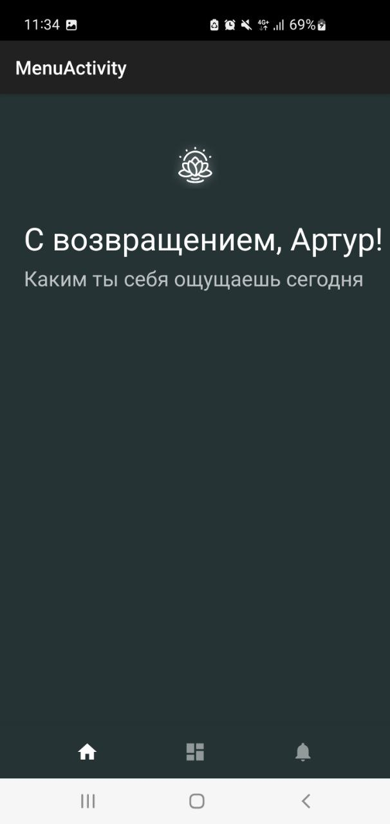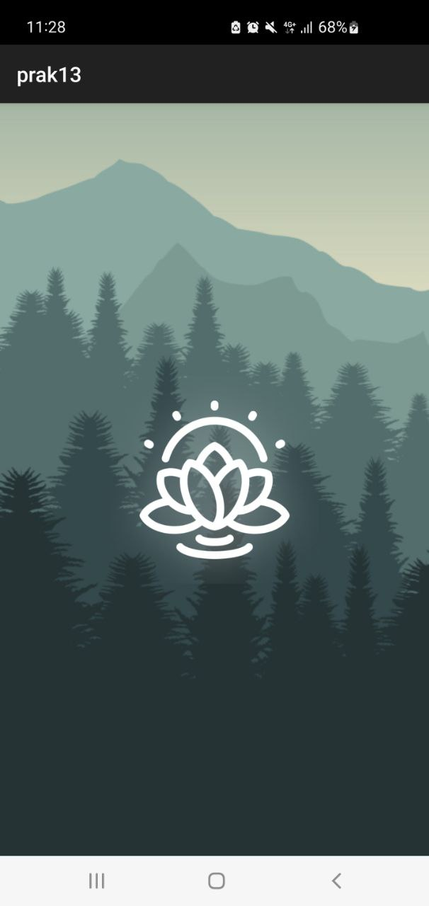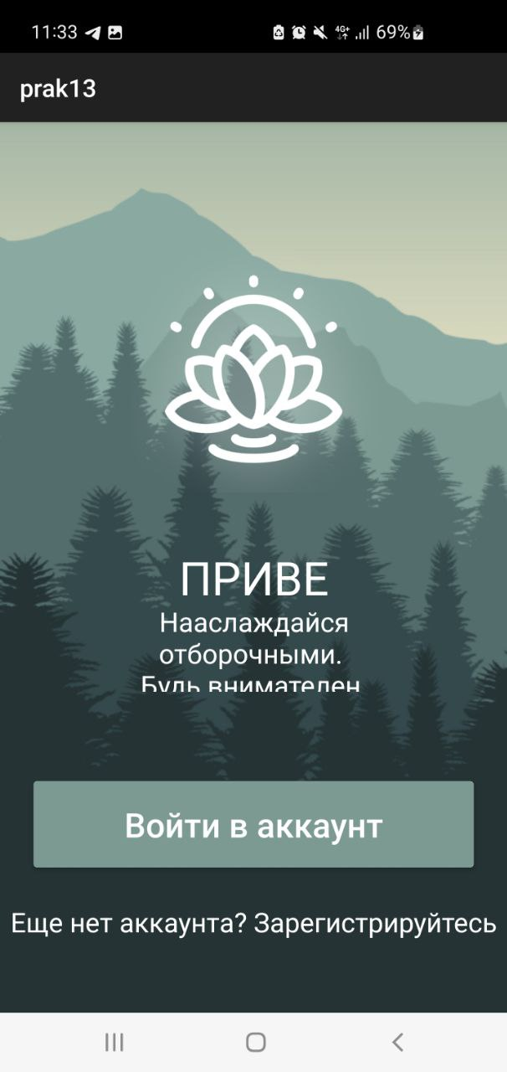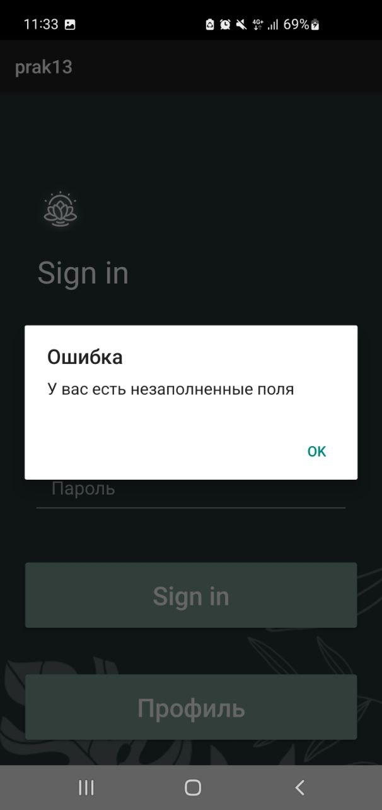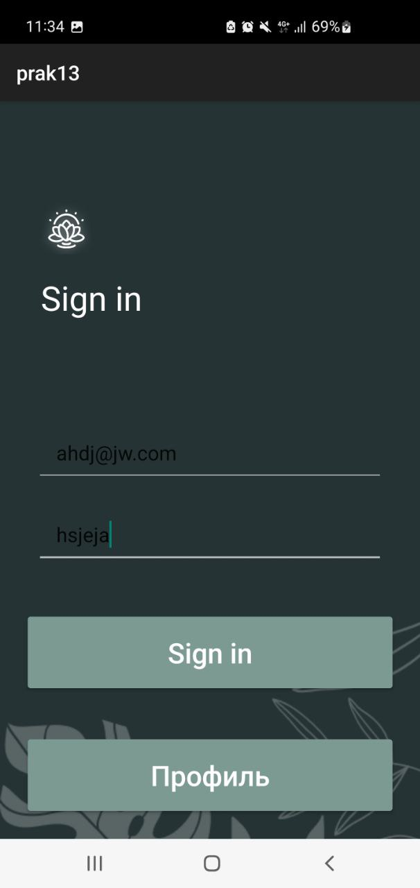

Задание 2:

На некоторых скриншотах может немного неправильно отображаться текст

Т.к. приложение было разработано под другой телефон!!!

